Name: _________________________Date: ___________Per: ______________
“No Witchcraft for Sale” By: Doris Lessing

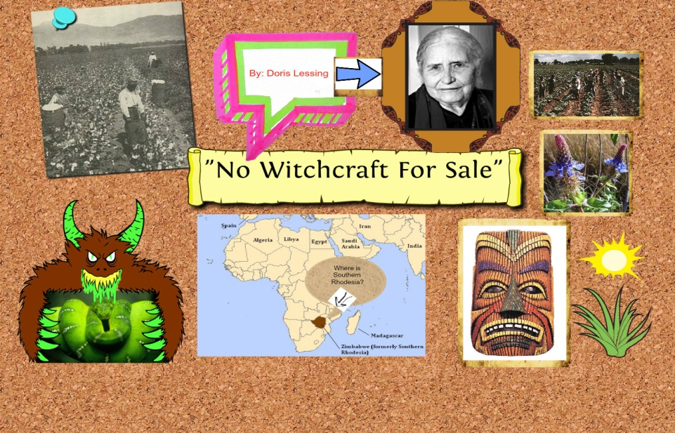
Task: Students will read 5 short stories that are multicultural in context. Students will form 5 groups of 5 and complete a mini- research project that will include the following criteria:

Author Information:
Doris Lessing was born in 1919 in Iran to British parents who
bought a farm in Rhodesia (now Zimbabwe) and moved there; in 1949 she moved to
England. She is still living and still publishing; she published another novel in 2008.

- Consider the following questions in relation to the brief author synopsis above:
- What is life like in Zimbabwe?
- What types of people live there?
- How do people “make a living” in Zimbabwe?
- What is one thing the people rely on most?
After researching the above what prediction can be made with the short author biography and the answers to the questions in relation to the short story?

In order to get a full understanding of the short story, prior to reading research the following:

- What is life like living on a homestead in Africa? Locate it on a map.
- What is a “medicine man”? How/why are they important to this culture?
- Investigate a folk medicine. Research a folk medicine and explain its historic uses, what plant it comes form and what is the medical purpose behind it?
- Look into cultural conflict. How does a native of the land treat their land versus someone, i.e. a scientist treat the land? Do scientists appreciate the land, nature and a natural medicinal ingredient like a native does?

***Now you are ready to read the story. As you read delve into these questions:
- How does ones cultural conflict bring about a difference in values and beliefs?
- In what ways do Gideon and the Fraquars differ?
- How are the reactions of Gideon and the Farquars similar and different when presented with the scientist’s request?
- Do you think Gideon’s decision to withhold information about the plant is justified? You must explain using evidence from the story.

Writer’s Craft is used in literature as a stronghold to convey the essentials one may need to know. As you read “No Witchcraft for sale” identify 5 writer’s craft elements and explain the importance of them to the overall meaning of the story.
- Theme-
- Imagery-
- Mood-
- Characterization-
- Verbal irony-

Helpful website/resources:
http://worldliteraturemultimediaproject.weebly.com/no-witchcraft-for-sale.html
Medicinal plants: http://fracturedparadigm.com/2013/05/19/27-medicinal-plants-worth-your-garden-space/#axzz2ZnD3C4BU
Medicine men: http://discovernavajo.com/a11.html

History of Zimbabwe: http://www.gta.gov.zw/index.php/zimbabwe-in-brief/history-of-zimbabwe

